MSU Extension’s Six-Step Community Change Model

Step 4: Gather Resources

Guide: Gather Resources
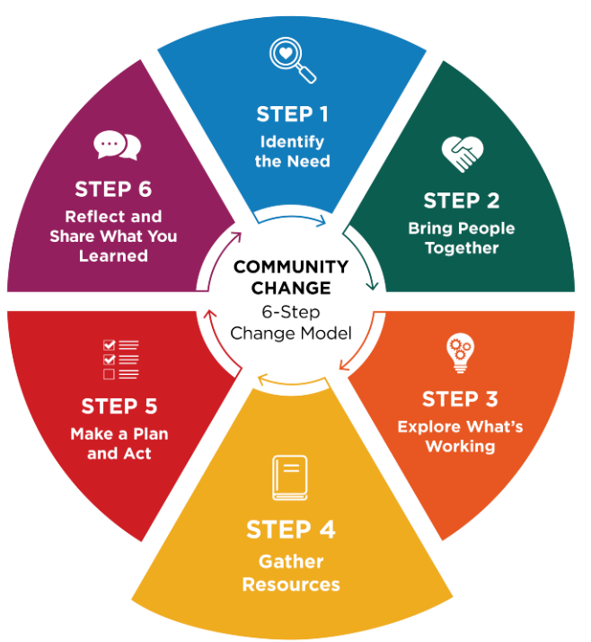
Community champions often know partners and are passionate about choosing practical strategies that fit the community.
Once you have explored what is working and what could be better, the next step is to decide what your group wants to do. Work together to choose realistic goal(s) and gather information that can help you reach it.

Look for reliable ideas and examples
Start by reviewing trustworthy resources, practical strategies, and real‑world examples. Talk with your group about tools or ideas that could move your goal forward. Ask if anyone knows another place — or a person — who has tried something similar.
You may also want to:
- Visit communities or sites that have used successful approaches
- Connect with community champions who have done similar change work
- Observe what makes their approach effective
Seeing what others have tried can spark ideas and help you understand what might work in your setting.

Use trusted sources
The MSU Extension Community Change Hub brings together trusted resources on school wellness, food access, active living, and early childhood health to help communities make informed decisions and act.
When reviewing additional online materials, look for resources that highlight research or evidence-based practices.
Reliable, evidence-based information often comes from:
- Universities
- Professional organizations
- Government (.gov) sites

Talk with your team about what fits best
Discuss what strategies feel like a good match for your group’s goals and readiness. Partners may know about resources that:
- Describe promising or evidence‑based strategies
- Provide funding or financial support
- Help plan or carry out the work
Choose options that feel realistic and doable for your group.

Questions to consider
As your group begins planning, the following questions can help clarify what’s required and where to focus your efforts.
Ask:
- What does the group want to change?
- What resources are needed for success?
- Will financial support be needed?

Worksheet: Gather Resources
Choose strategies that fit your setting and identify tools/partners to support action. Champions help determine fit, connect to resources, and communicate the plan.

1. What kind of change are you trying to make?
Choose one or more that apply. This helps identify strategies that last.
- Change the rules, expectations, or policies (guidelines/standard practices/written procedures)
- Change the routine (schedules, workflows, checklists, or meetings)
- Change the space or what’s available (supplies, signage, room setup)
- Not sure yet

2. Decide on ONE clear goal to focus on first
It helps to begin with the desired change and decide on a goal that feels doable, useful, and meaningful for the people involved.
Goal: ____________________________________________________________________________

3. Consider examples of what works for others
Review the suggested examples and strategies provided in these four MSU Extension Community Change Hub areas of practice:
- Champion Early Health
- Champion School Wellness
- Champion Food Access
- Champion Active Communities
Then, come up with some ideas that may work for your change initiative.
Idea 1: ___________________________________________________________________________
Why it fits: ________________________________________________________________________
Idea 2: ___________________________________________________________________________
Why it fits: ________________________________________________________________________

4. What barriers might get in the way?
Choose all that apply.
- Time
- Space
- Staffing
- Money
- Buy-in
- Knowledge/skills
- Other: ___________________________

5. Choose ONE example or strategy to guide your next step
Resource name: ___________________________________________________________________
What you plan to use from it: _________________________________________________________
_________________________________________________________________________________

Reflection
- Are there barriers to moving forward such as readiness, time, money, people you have at the table? If yes, should you identify a different goal?
- Do your resources support moving forward?

